Writer Box
(text editor with version control)

Sandeep Roy
(Roll No.: 16MCA032)



DEPARTMENT OF COMPUTER SCIENCE
FACULTY OF NATURAL SCIENCES
JAMIA MILLIA ISLAMIA
May, 2019
Writer Box
(text editor with version control)

by

Sandeep Roy
(Roll No.: 16MCA032)

Submitted
in partial fulfilment of the requirements of the degree of
Master of Computer Applications (MCA)
to the

Department of Computer Science
Faculty of Natural Sciences
Jamia Millia Islamia,
New Delhi- 110025
May, 2014
DECLARATION

I, Sandeep Roy, student of M.C.A hereby declare that the project report entitled “Writer Box(Text Editor With Version Control)” which is submitted by me to the Department of Computer Science, Jamia Millia Islamia, New Delhi, in partial fulfilment of the requirement of the degree of Master of Computer Applications (MCA), is a record of the original bonafide work carried out by me and have not been submitted in part or full to any other university or institute for the award of any degree or diploma.

(Sandeep Roy)
Roll No: 16MCA032
Enrollment No.: 16-0299

Certificate
On the basis of declaration made by the student Sandeep Roy, I/we hereby certify that the project report entitled “Writer Box” submitted by Sandeep Roy to the Department of Computer Science, Jamia Millia Islamia, New Delhi, for the partial fulfilment of the requirements of the degree of Master of Computer Applications (MCA), is carried out by him under our guidance and supervision. The report has reached the requisite standards for submission.

Dr. Syed Zeeshan Hussain  (Internal Supervisor) | Ms. Ayushee Rastogi (External Supervisor)

ACKNOWLEDGEMENT

I gratefully acknowledge for the assistance, cooperation, guidance during the development of the Text Editor. My extreme gratitude to Ms. Ayushee Rastogi who guided me throughout the project. Without his willing disposition, spirit of accommodation, frankness, timely clarification and above all faith in me, this project could not have been completed in due time. His readiness to discuss all important matters at work deserves special attention.

I am also grateful to VectoScalar Technologies for providing me with an opportunity to work with them and undertake a project of such importance. I wish to extend my sincere gratitude to Dr. Syed Zeeshan Hussain my Faculty coordinator for his guidance, encouragement and valuable suggestions, without which this project would have been a distant reality. I would also like to express my appreciation and admiration to all my friends and colleagues whose support and encouragement have been a constant source of assurance, guidance and strength to me which led to a wonderful experience during the tenure of this internship.

Sandeep Roy
(16MCA032)

Contents

- Introduction
  - About Company...................................................................................
  - Problem Statement................................................................................
  - Proposed Solution.................................................................................
  - Deliverables.........................................................................................
- Project Description
  - System Interface..................................................................................
    - Architecture...............................................................................
    - User Interfaces...........................................................................
  - System Specification............................................................................
    - H/W Requirement.......................................................................
    - S/W Requirement........................................................................
  - Methodology and Tools Used.................................................................
    - Methodology Used......................................................................
    - Architecture Used........................................................................
      - Data Access Layer..............................................................
    - Requirement Phase.......................................................................
      - Functional Requirements......................................................
    - Design Phase ..............................................................................
    - Development Phase........................................................................
    - Implementation Phase........................................................................
    - Testing Phase....................................................................................
      - Unit Testing........................................................................
      - Integration Testing............................................................
      - System Testing........................................................................
  - Constraints ................................................................................................
    - Assumptions and dependencies............................................................
    - User Characteristics........................

- Functionality
  - Logical Database Design
  - Functionality
    - Modules
    - MODULE DESCRIPTION
      - Editor Module
      - Asynchronies linker
      - Version Control Module
      - Auth Manager
      - Database Storage
      - FAT file manager
      - DRM module

CHAPTER 1: INTRODUCTION

1.1 About the Company
VectoScalar Technologies Pvt. Ltd. is a bunch of techies who love to code and design applications. VectoScalar’s primary focus is Mobile (IOS & ANDROID) and Web development. We put a lot of focus on design, writing object oriented and flexible code. We just want our clients to have a seamless and smooth experience working with us.
Our strength is building robust and fast IOS and Android Applications. We keep ourselves up to date with upcoming iOS enhancements and SDK. We possess all the required tools to build/test iOS and Android applications on different versions. Every resource at VectoScalar goes through a rigorous training process regardless of his experience. We also make sure every resource explores and gets training on new iOS and Android updates.
We have a team of Web developers who have a great experience in building web applications in Django, python, AWS, Java. We have worked with many clients and are currently working on couple of redesigning Web applications. We have also ported web applications to HTML5 and reskinning.

1.2 Problem Statement
Writing a book or research paper is a huge project every writer spent lot of time only for writing and editing same paper. And for comparing new changes with previous one they need to create a new copy and edit that document in ms word or other editor until they don’t have a version control like git which can be implement with all word editor. Every writer or editor has face this problem while doing there project.

1.3 Proposed Solutions
We will focus to create a version control tools that help a team manage changes to main draft over time. Version control system keeps track of every modification to the code in a special kind of database. If a mistake is made, editor can turn back the clock and compare earlier versions of the code to help fix the mistake while minimizing disruption to all team members.
For almost all writing projects, the central draft is like the crown jewels and a precious asset whose value must be protected. For most writing teams, the source code is a repository of the invaluable knowledge and understanding about the domain that the editors have collected and refined through careful effort. Version control protects the project from both catastrophe and the casual degradation of human error and unintended consequences.

1.4 Deliverables
- Preliminary & Intermediate Report
- An editing software with version control that can be used for creating any type
of documents.
- Final Project Report

Chapter 2. Project Description

2.1 System Interfaces
The system is developed by layered approach. Basically it contains these layers: Data Access Layer + Business Logic Layer (Backend), Linker and User Interface Layer (Frontend).
The Database used in this Application is SQLite. Data Access Layer (DAL), provides the interface to the Business Logic Layer (BLL) and the Database.

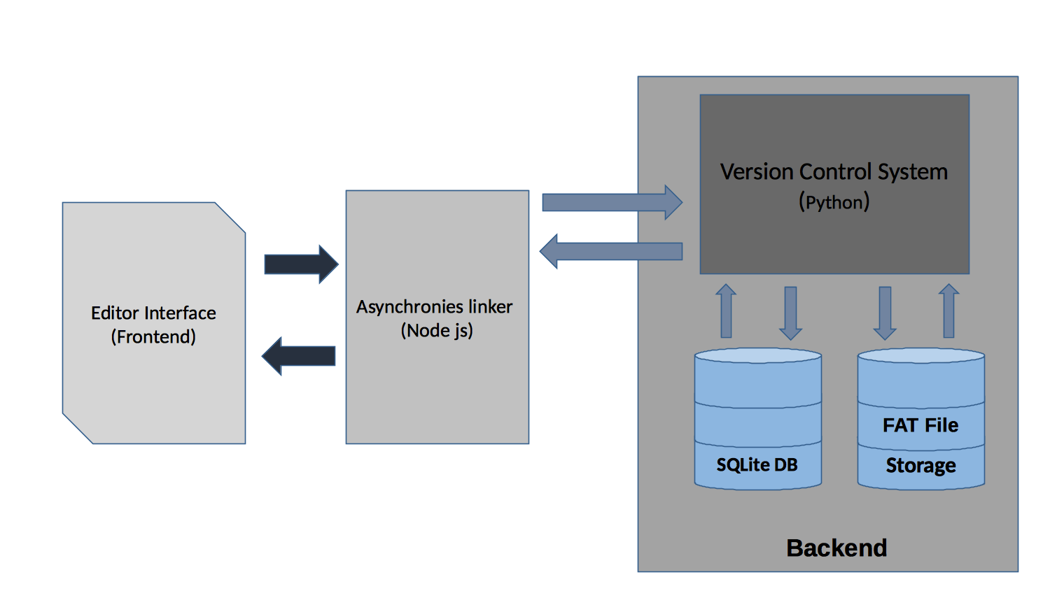

Fig 2.1 Concept Diagram

2.1.1 Architecture
The microkernel architecture pattern is a natural pattern for implementing product-based applications. A product-based application is one that is packaged and made available for download in versions as a typical third-party product. However, we can also develop and release any internal business applications like software products, complete with versions, release notes, and pluggable features. These are also a natural fit for this pattern. The microkernel architecture pattern allows you to add additional application features as plug-ins to the core application, providing extensibility as well as feature separation and isolation.

2.1.2 User Interfaces
The application has user friendly interface where any newbie can easily understand and use functions
- The home page is a blank editor page so that user can easily start writing and crafting there idea.
- Left side of the editor show all open files with a selected folder.
- Right panel of the editor has change activities which shows version or user draft (if any) with there saved name in descending order of save dates.
- Header has space of page title, button for manage changes and a protector button which will encrypt entire file.
- Bottom bar of the editor has four features for now
  - Choose branch
  - show changes
  - and format of the file

2.2 System Specification

2.2.1 Hardware Requirement

Hardware | Specification
CPU | Intel Core i3+
RAM | 2 GB+
HARD DISK | 128 GB+

Table 2.1 Hardware requirements

2.2.2 Software Requirement
 | MODULE | VERSION
Operating System | Microsoft Windows/Linux/Mac | -
Database | SQLite | 4.0.6
Chrome Engine | V8 | -
Source Repository | Git | -
IDE | VS Code | 1.1.3
Electron | Chromium and Node.Js | 5.0.1
Node Js | Node | v10.5.3
Python Environment | Virtual env | Python 3.7

Table 2.2 Software Requirements

2.3 Methodology and Tools Used

2.3.1 Methodology Used

The concerned Project uses Agile methodology of iterative development where requirements and solutions evolve through collaboration between self-organizing cross functional teams. Agile web development is a model for development of web applications. It is more efficient and powerful within a shorter timeline than other models and incorporates face-to-face communication, and includes technical personnel as well as customers as part of the team. Agile web development uses project managers, business analysts, emphases on clear goals, planning, and iterative delivery. Agile web development ensures the successful completion of product at the end of each iteration.

2.3.2 Architecture Used
2.3.2.1 Microkernel architecture
An application has a core set of operations that are used again and again in different patterns that depend upon the data and the task at hand. This editor tool, for instance, will open files, annotate them, edit them, and start up background processors. The tool is famous for doing all of these jobs with Python and Node.js code and then, when a button is pushed, compiling the code and running it.
In this case, the basic routines for displaying a file and editing it are part of the microkernel. The Python interpreter is just an extra part that’s bolted on to support the basic features in the microkernel. Other features support by Node js(electron) so that it can have the benifits of native OS file manager like read, write and edit files.
We are designing this editor in such a way that extra features can be layered on top, we often called plug-ins.

2.3.2.2 Caveats
- Deciding what belongs in the microkernel is often an art. It ought to hold the code that’s used frequently.
- The plug-ins must include a fair amount of handshaking code so the microkernel is aware that the plug-in is installed and ready to work.
- Modifying the microkernel can be very difficult or even impossible once a number of plug-ins depend upon it. The only solution is to modify the plug-ins too.
- Choosing the right granularity for the kernel functions is difficult to do in advance but almost impossible to change later in the game.

2.3.3 Requirement Phase
- Use Case Model: Use case models enable you to explore how users will work with your system. Use cases have been defined for different work scenarios under this model.
- Initial Domain Model: This defines the fundamental business entities and relationship between them. The way classes are interacting to provide the functionality.
- Editor Structure Model: Editor Structure Diagram has been defined which shows the overall structure of the applications and lists all the screens that can be accessed by the users. This tells how layers are packaged in the project.

2.3.3.1 Functional Requirements
User need to add his/her email and password with a single application which will be use future for:
- To match user with centralize server
- To store local work with royalty
- To store branches and draft versions

2.3.4 Design Phase
Agile Design Model is followed with a Test Driven Design Philosophy. Under this model Unit testing is performed along with Design and development of functional units in parallel. The first step is to quickly add a test, basically just enough code to fail. Next new tests are run to ensure their failure. You then update your functional code to make it pass the new tests. The fourth step is to run tests again. If they fail, we update functional code and retest. Once the tests pass the next step is to start over with a new test.
Design phase commences after the requirements are finalized and frozen. The design phase attempts to uncover various entities involved in the system and their associated behaviour and also the interfaces that would be provided by the system. ER Diagram and data flow diagrams for the systems are developed. Database tables and relationship between them is also defined.

2.3.5 Development Phase
The System is developed as 3 layer with bottom up strategy defined as follows:
Data Access Layer and Business Logic Layer (Backend), Linker and User Interface Layer (Frontend)
- Data Access Layer and Business Logic Layer (Backend): A data context is defined on this layer which manages connections to the Tables in Data Base. For accessing the data python is used, it provides object relational mapping and an easy way to access the database. And if we want to extend our database with requirements then changes to be made to use that would be minimal and would not affect the already existing code.
- Linker: This layer acts as a bridge between interface layer and the Data Access Layer. And to complete his we mainly use Node.js. All Business and Modification logic has been applied under this layer. Over here API’s are defined so as to access data from DAL and restructure it so that it can be used in presentation layer.
- User Interface Layer: This layer defines generic interface with which user interacts. It is as classes which define functions for presentation of data retrieved from business access layer to user. This is implemented with help of HTML/CSS/JS in Electron Framework.

2.3.6 Implementation Phase
The System is implemented on chromium V8 engine in incremental fashion. The user interact with editor main frame. So to store user’s change we use SQLite. Our micro-services architecture pattern provides great support for evolutionary design and incremental development. We first produce a solid core system, and as the application evolves incrementally, add features and functionality without having to make significant changes to the core system.

2.3.7 Testing Phase

2.3.7.1 Unit Testing
Unit testing at Data Access Layer was performed on the Procedures before being added to context to check their direct working on Databases. At Business Logic Layer Unit Testing was performed on Various Business and Edit Objects using Drivers at Interface Layer to test the retrieval and accuracy of data at the data Access Layer. To store branches and draft versions.

2.3.7.2 Integration Testing
Integration testing within the deliverable involved integrating all the layers and to check the secure flow of Information under the defined roles defined. Integrity checks were tested on the Data Passed to the Data Access Layer from the User Interface Layer.

2.3.7.3 System Testing
System Testing was performed under the deployment environment to check for acceptance under different environment

2.4 Constraints
- Display of content varies from OS to OS it was developed in OS X so all compatible for this OS. To make it compatible we need some minor changes.
- Difference is checked under some known circumstances. So we are working on this for future release.
- Testing process is carried out on a limited scenarios may contains some bugs.

Chapter 3. Functionality

3.1 Logical Database Design
- Document: Stores all document with file name, file location, status and project_id with unique doc_id.
doc_id will be the primary key
- Staged: This is the second level of user change for merge. Mainly use for reivew the changes.
Stores: doc_id, last_version saved by user, diff(new changes in file)
doc_id is foreign key.
- Merged: When user store changes in file permanently it will store commit_id against doc_id
doc id is foreign key.
- Version: Stores difference in file with a new version id of file with user_id. Has many to one relation with document table.
doc_id and user_id is foreign key.
- Authenticated: Credentials table which store username, email and password with unique user_id (generated in backend)

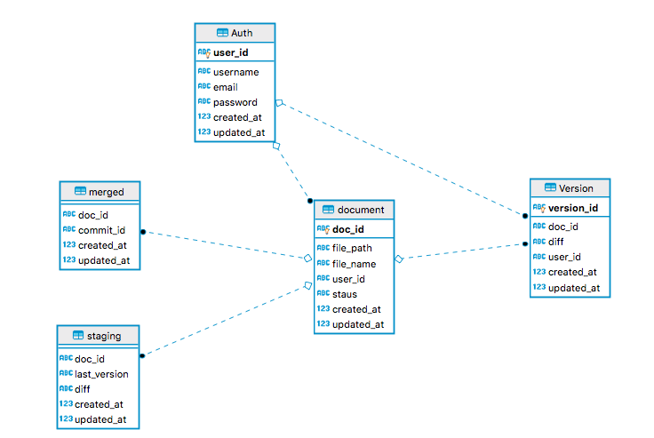

Fig 31. Database table diagram

3.2 Functionality

3.2.1 Modules
The project has following modules: -
- Editor Module
- Asynchronies linker
- DRM module
- Version Control module
- Auth Manager
- Database Storage
- FAT file manager

3.2.2 Module Description

3.2.2.1 Editor Module
We have an editor which has all features need by a writer. When new user open the application it show blank page where user can create there master piece.
- Right Click: One of the most important feature for users. Just by clicking on right side it will pop up small menu for:
- Add link
- Insert Table
- Add Rows
- Add column
- Add cell
- Delete table(activate if table exists)

- Editor Menu: This Contains all the feature given in editor in form of pop menu where users can find there all option need to craft any script.
- Files
- Edit
- View
- Insert
- Format
- Table

- Buttons bar: This bar contains shortcut buttons to edit text faster. It contains
- Drop down menu of font size
- Italic
- Strikethrough
- Under line
- Bold
- alignment buttons
- Toggle list(orderd and unordered)

3.2.2.2 Asynchronies linker
This module is act like a bridge between frontend and backend processes. This Module is writing in Node JS which is complete independent backend. Hence if any case future developer want’s to add new processes in back-end with different programming language can easily program without worry about frontend changes.

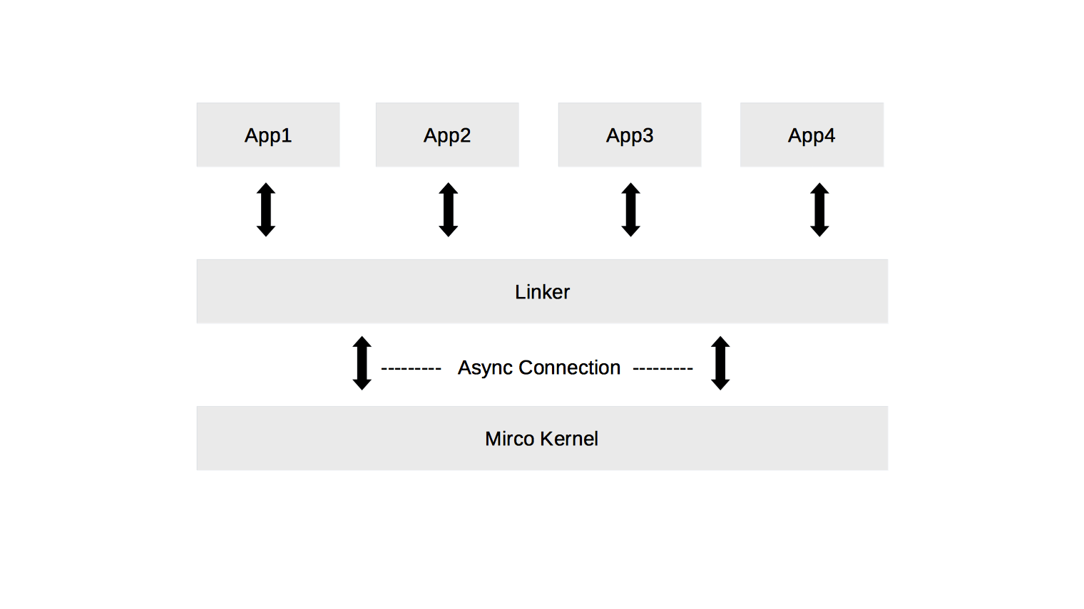
Fig 3.2 Linker Flow

Here is more detailed explanation of the steps in the diagram:
- App send request to linker. Linker diverts incoming requests to appropriate function.
- Those App which depends on other app response or result can send synchronize requests.
- Apps could be build in any programming language but have to follow sudden guidelines.

3.2.2.3 Version Control Module
This is the most important module in this project which will work on event.
This created to monitor all changes like addition, deletion or changes in a file. It will start tracking new file when user save them before saving it was untracked.
Functions of this module:
- Maintain the record of merges and commit with essential location.
- Stage local change for user review
- Find difference between last version and new file version.

3.2.2.4 Auth Manager
Users need to add there user name and password so that users save there work with royalty. In future we will connect this system with centralized server so this user name, email and password will be user as identity.

3.2.2.5 Database Storage
We store SQLite to store meta information about the project like path, file version, is_staged, created_at, difference etc.

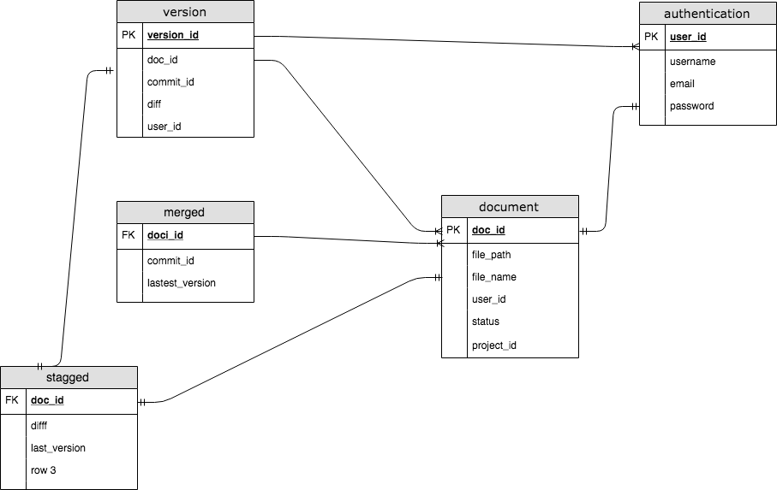
Fig 3.3 ER-diagram

3.2.2.6 FAT file manager
This module design to monitor to store, open and create file in Secondary memory of Machine. This also create to provide shortcuts like Ctrl+S to save, Ctrl+N to create new file, Ctrl+O to open stored file in system.

3.2.2.6 DRM module
Digital right management (DRM) is useful in today’s world where copyright is main issue. So to explain this module we explain this in next chapter.

Chapter 4. Digital Right Management(DRM)

DRM System will be responsible for the security and delivery of the E-Books (Epub file) to the clients. It will also handle some business rules for the delivery of e-books.

4.1 Workflow of DRM

- Client will call API Server to access the e-book
- API Server will track the user, its device and prepare the manifest file and encrypted-e-book with help of DRM module/server.
- Client will receive the manifest and s3 url for ebook
- Client will read the manifest which will contain all the related information for e-book and present it to user.
- Once user requests the book, client will read the received manifest file and will try to decrypt the e-book. If the client is not able to decrypt the manifest file or the e-book file, client will prompt the user and ask to download new manifest. (Client will also validate signature and hash for the manifest and e-book file to validate the authenticity of files.)
- On re-request of manifest, server will validate the number of devices on which manifest is already served. If number of devices already registered is more than 5 then it will throw some error that will be handled gracefully by client. Client will receive error message on device and will show appropriate disclaimer on UI.
- Client will also store static public key with code. Server will send the signature for manifest and e-book and client will verify its signature with this public keys. Server will store the private key part securely to create the signature.

4.2 E-Book Bundle
There are 2 major parts of e-book bundle:
- manifest (encrypted)
- e-book (encrypted)

4.2.1. Manifest
The manifest contains general information about the files. It has a version number. It includes signatures for all the bundle file.

It has information about the file type, salts needed for decryption, content-type, a signature to ensure the file wasn’t modified, and so on. Signature will be generated using RSA with SHA256 With RSA algorithm. (This uses the private key). This private key will be securely saved to server, and its corresponding public will be shared with clients. Other can not create same signature for contents because private key is only available to server.

Manifest file will also contain general information about the e-book like description for book, authors etc.

The manifest json is returned in the download ebook response with a signed s3 url for the encrypted e-book from which the ebook bundle can be downloaded.

Manifest file will be encrypted using DeviceId + BookId + UserId + PreDefinedKey. So, that the manifest will remains unique for each device and will not be shareable among user or devices. Predefined key will some fixed text just to add few extra thing in key and will be saved securely (May be in NDK itself)

Manifest.json Structure:
{
“version”: “0.1”,
/*
* Digital signature of all the files in this ZIP combined, excluding this title.json
*
*/
“signature”: “43784acd73e44732232ffef3ac”,
“userId”:”user123”, /* hex of the client downloading the book */
“deviceId”:”dev-3923”, /* Target device id */
"ebookId": "book123", /* the unique book uid */
"ebookDownloadUrl": "https://ebookBundleUrl",/* the generated signed s3 url*/
"salt": "5C2DF18D157758B6", /* the salt to decrypt the watermarked key */
“iv”: “83892423...3242342332”, /* Initialization vector required for AES CBC */
"author": "ABC",
"description": "XXXX",
"category": "ABC",
“Key”: “xyz”
/*
*
* Signature is using RSA algorithm, signed by DRM Server. *
* Encrypted file is signed, not plaintext.
* This means client must not try decryption if signature does not match
*
* Public key will be hard-coded in Client app. (This should be available to each client)
* Obfuscation not needed since this is public key
*
*/
}

4.2.2 Security

4.2.2.1 Encryption
All files will be encrypted using AES-256 encryption, in CBC mode, with PKCS7 padding. The key will be derived from the <book unique key> + “Some random data”
Encryption will require a random 8 byte Initialization Vector(IV). IV will be unique for each file and the IV will be included in the manifest.json. The manifest will be returned as a json response to the download ebook bundle.

4.2.2.2. Signatures
Every file, whether encrypted or not, will be digitally signed. The signature will be based on SHA256WithRSA algorithm. RSA will use 2048 bits.
The private key will be kept confidential on the DRM server side. The public key will be made available to DRM clients. This need not be kept secret.
DRM clients are expected to do the following -
- Verify the signature of a specific file using the provided signature just before attempting decryption
Verifying / Generating Overall Signature
- Generate SHA256 hash of the contents of epub file.
- Verify the signature and hash for files with value mentioned in manifest json.

Signatures should be verified once the ebook is downloaded, and once again when the ebook is about to be opened.

4.2.2.3 Decryption
Before attempting decryption, Client must verify the signature of the file.
To decrypt the ebook bundle, Client will need the password that will be shipped in manifest file.
It will decrypt the manifest file with constructed password (deviceId + UserId + BookId + PreDefinedKey) using AES-256 / CBC / PKCS7. And then it will read the salt and initialization vector from manifest.json required to decrypt the e-book file.
The decrypted contents from the manifest will also give the actual password for the ebook-file. (Password for ebook-file will be bookUniqueKey + some random data derived with PBKDF2 algorithm).
The decrypted contents must never be written to disk. The key derived must not be written to disk either.
In case the client crashes, we will need to decrypt the ebook bundle once again.

4.2.2.4 Certificate re-request
There are instances when user will copy the files from one device instance to another. When user will try to decrypt the manifest file on another device then it will fail as certificate will be encrypted with device id and user id. In this case client will have to re-request the certificate from DRM server.

4.2.2.5 Key derivation algorithm
PBKDF2 algorithm (with 100 rounds) hashed and the hash along with the salt will be used to derive the key from the base text (UserId, deviceId or for unique book password key)

4.3. Downloading, Partitions and Retries

4.3.1 S3 Storage
We will store the encrypted ebook bundle in S3 in private buckets. When you call the download book API, we will:
- Authenticate you
- Ensure you haven't already downloaded the book based on device restrictions (and other authorizations and access rights check).
- Create a signed S3 link that is only valid for 1 hour.
- The S3 url will be returned as part of the response to download bundle API. In other words - Client will be downloading the book from S3

4.3.2 Partitions
Normal HTTP protocol will be used to download the file form s3. S3 should support multipart (chunk) downloads.

4.4 Client

4.4.1 Introduction
For client to work with our custom DRM. We are introducing a new class: DRMManager. (Singleton/Static class for handling our custom DRM logic)

4.4.2 DRM Manager
Prototype to use DRMManager
final File book = new File(getExternalFilesDir(null), "test.epub");
DRMManager.setupBook(MainActivity.this, book, true, new DRMManager.CallbackType() {
@Override
public void onSuccess() {
ReaderActivity.startActivity(MainActivity.this, book);
}
@Override
public void onFailed() {
Raise Error()
}
});

Public Methods:

Setup Book:
This function will take following arguments
- Activity context
- File (epub)
- Callback object

Once this function is called, This will call some NDK functions to validate the signature for epub file, and to gather the key that will be used to decrypt the file contents. This function will also create a zip file pointer for epub file.

This function will not return any data but call the success or failure callback based on validations and key derivations. Callback should be handled gracefully by the caller classes.
getStreamForPath:
This function will only take path argument. This path should be the path of resource file in the epub.
As a precondition, setupBook function must be called before calling this function. This function will read the content of file from zip file pointer (already created in setupBook function) and then the bytes (file content) will be passed to NDK to get the decrypted content. NDK will have the respective keys and information to decrypt the content (as in setup function we will initialize these.) decrypted content will be returned as stream.

cleanup:
This function will not take any argument but will clean all the initialized pointers/variables.

Modification in ReaderModule
Class: ReaderHTTPServerAsync.java
Function: @Override public void onRequest(
final AsyncHttpServerRequest request,
final AsyncHttpServerResponse response)

This function is responsible for providing data to the Reader. So, currently if file is coming from the epub then we are reading it with “pack.getInputStream” instead here we will read data from DRMManager.
“InputStream stream = DRMManager.getStreamForPath(path);”

This stream will be passed to response. DRM Manager will return the decrypted contents that will get passed further, Thus reader will eventually gets plain text content.

4.5 Rest Api’s

- POST {version}/api/download/{bookId}
Request: {
“deviceId”: “xyz”,
}
Response:
Manifest file data
Authentication: User Authentication.
Status Codes: If successful, will return a 200.
4xx in case the fields are missing or the url is invalid.
5xx if it's a problem with the API
Validations: Validation for user, (authentication) and access rights.
Internally, the API will fetch related informations for user and corresponding ebook file, prepare the password that can decrypt the e-book and encrypt it based on userId, book id, deviceId and some predefined text along with required salt and IV (Initialization vector).

4.6 AWS CloudFront
We will utilize AWS Cloudfront for fast and easy delivery of e-books.

Chapter 5. Testing

5.1 Testing Activities
- Project Initiation: Testing Targets were set during this phase. From the point of view of testing the main tasks were to organize the approach towards testing. As we had not package the project for a specific environment. So we test it in unit wise and after integration.
- Development team Testing: In this strategy testing was done by us only for all the targets for the test cases defined later in this chapter.
- End-of-lifecycle Testing: As part of end of lifecycle testing the application was given to peers to test for all the test cases decided.

5.2 Unit Testing

5.2.1 Methodology Used
Unit testing is carried out by the developer in the developer environment only. Manual testing was done. The developers reviewed code to check whether our respective units under tests behave as expected.

5.2.2 Tools Used
Not Applicable. Manual testing was done.

5.2.3 Test Cases

Test Id | Test Case Name | Test Case Description | Expected Output
1 | Open Screen | Open screen should be a blank screen | Blank Screen with empty title bar
2 | Editor Screen test | After integrating editor it should align between left and right panel | Editor should be middle of the screen with proper margin
3 | Indentation test | Heading ,paragraph , order and unordered list should be properly intended | Heading should 4 cols  paragraph should 2col  list should 1col intended
4 | Alignment test | When we click on button it should properly align | Left align must be at extreme left, and for right and middle also.
6 | CMD + S | Error if system is out of space | File Path
7 | CMD + O | Open system file dialog | 1
8 | CMD + N | If file is not saved then open save dialog else show error | Open Empty screen
9 | Register | When user try to store file it first should check user authentication else return auth error. | 1
10 | Open Files | Left panel contains open file when we click on any file it should return path | Return File path
11 | Quit application | When user close application it will save all change and close connection if any app is not close then return error | 1
12 | Diff store | Get difference between the files | Return place value json
13 | Store path | When user save file it shore absolute path of file | Path of file in string format
14 | Show button | When user click show button it will return 1 if active else return 0 inactive | 1 or -1
15 | Show changes | Show live change by user | Difference between old file (json format)

Table 5.1: Unit Testing Test Cases

5.3 Integration Testing

5.3.1 Methodology Used
For use integration test bottom up approach was used where the lowest level components were tested first, and then used to facilitate the testing of higher level components. The process was repeated until the component at the top of the hierarchy is tested.

5.3.2 Tools Used
Not Applicable. Manual testing was done.

5.3.3 Test Cases

Test Id | Test Case Name | Test Case Description | Expected Output
1 | Integration all panels in front end | After integration all should properly aligned with properly margined | Appears
2 | Left panel dynamic file name | When a file is saved it must show at left panel under open folder | Appears
3 | Admin able to save changes | Add/update/delete file | Appears
4 | Version Control | When user store changes it will update changes in database | Store
5 | Protect File | When user click protect button it will store file in encrypted form | Encrypts file

Table 5.2: Integration Testing Test Cases

5.4 System Testing

5.4.1 Functional Testing
5.4.1.1 Methodology Used
Under this the whole system is tested by our testing team. Basically all functionalities as per requirements were tested here.

5.4.1.2 Tools Used
Not applicable. Manual testing was done.

5.4.1.3 Test Cases
Test ID | Test Case Name | Test Case Description | Expected Output
1 | Admin has complete control | Admin should have complete control over  System | All Admin  Management  functions available
2 | User can see changes | User should be able to view changes | User able to request and view changes
3 | User can store version | User store there changes in draft format | User able to see those changes
4 | User must login before store file | User have to logged in before storing file | User not able to store change when not registered
5 | User can see any versions | User should able to see changes and merge history | User able to see any historic changes

Table 5.3: Functional Testing Test Cases

5.4.2 Non Functional Testing
5.4.2.1 Methodology Used
Under this the whole system is tested under the development team. Basically all functionalities as per requirements are tested here.

5.4.2.2 Tools Used
Not Applicable. Manual testing is done.

5.4.2.3 Test Cases

Test Id | Test Case Name | Test Case Description | Expected Output
1 | System Stability State | System’s Ability to Recover and save Last State | System recovered successfully

Table 4.4: Non-functional Testing Test Cases

5.5 Implementation
The tests were first implemented on individual units under Unit Testing. Each of inputs were divided as Valid or Invalid Inputs and then a combination of these was tested upon the concerned Functional Modules. The results of these inputs were described in test case results area.
Under System Testing the complete Functionality of the system as per the requirements was tested. Each and every requirement was studied and its implementation with the concerned functionality was provided.

CHAPTER 6: CONCLUSIONS

6.1 Conclusion
Writing a book or research paper is a huge project every writer, they spent lot of time only for writing and editing same paper. And for comparing new changes with previous one they need to create a new copy and edit that document in ms word or other editor until they don’t have a version control like git which can be implement with all word editor. Every writer or editor has face this problem while doing there project.
So we try to fix this in by creating a version control system. But while we are doing that we understand that protecting user data is also equally important so we move ahead to create DRM module. Now our main focus will be make this editor useful for all those who ever write or edit something

6.2 Limitations of the System
- Not linked with centralize system so user can only see his/her own changes
- User interface has some bugs when we scroll page.
- Couldn’t share with direct link.
- Not implemented for cross platform service.
- Multiple users not able to work together

6.3 Future Scope
- We will setup a centralize server which will make this application distributed.
- Collaborative editing module will be added so that users can work together.
- Socket programming will be use so that users work will be saved in server directly.
- Link share will be added so that user can easily share there work
- User interface will have more option and buttons.
- Branching system will be implemented.

CHAPTER 7: REFERENCES
Links
- Electron Documentation.
- O’RELLY online library, www.oreilly.com/library/view/software-architecture-patterns
- Python Official Book: https://wiki.python.org/moin/PythonBooks
- Amazon Web Services Documentation, https://docs.aws.amazon.com/index.html

Books
- Learning Python, 5th Edition Fifth Edition by Mark Lutz
- Digital right management. https://web.archive.org/web/20160611154507/http://202.206.214.254:8089/GYZJ/NEPAPER/papers/096e-Braid.pdf
Screenshots

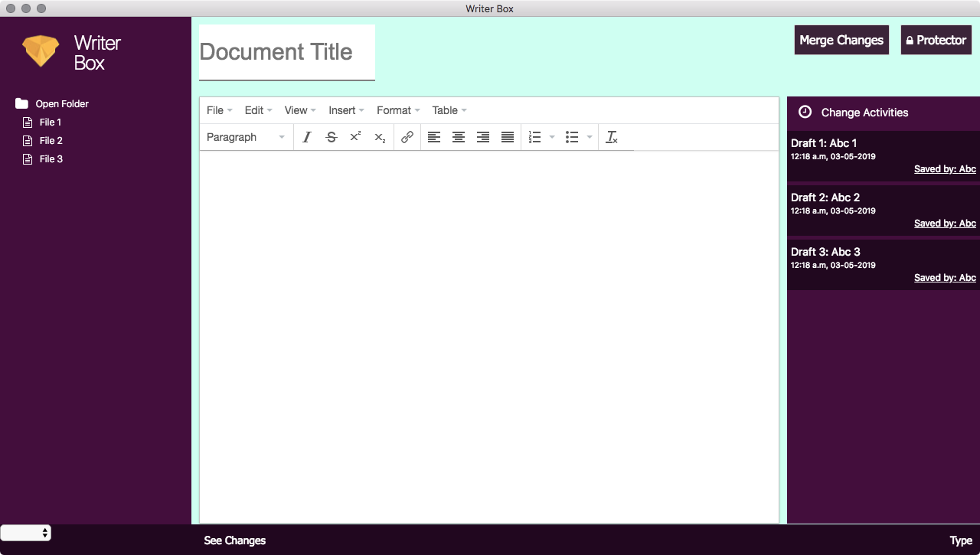
Fig1. New Screen

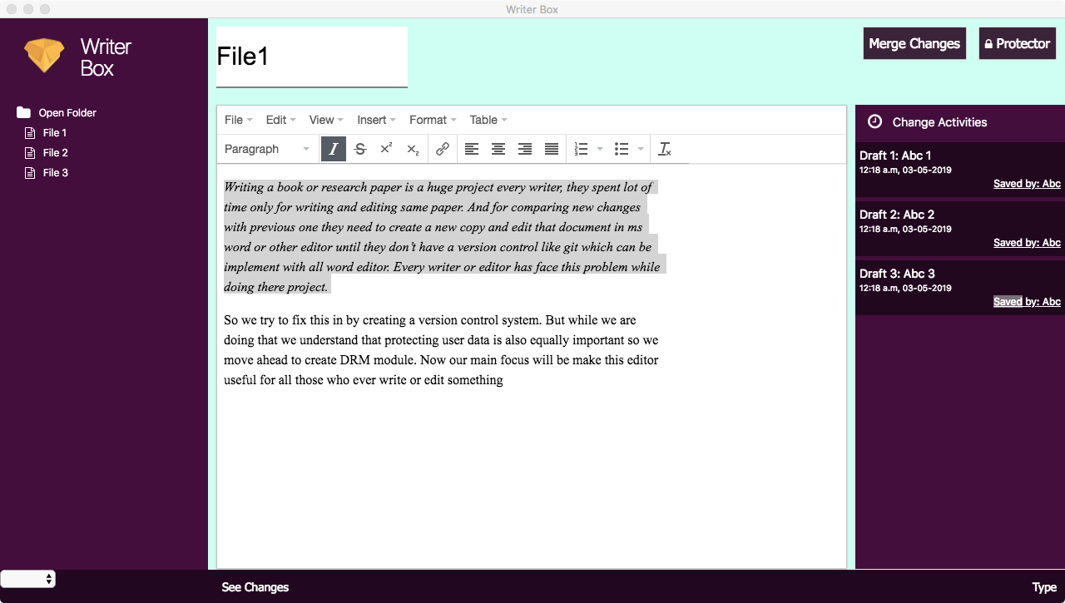
Fig 2. Shortcut button(italic demo)

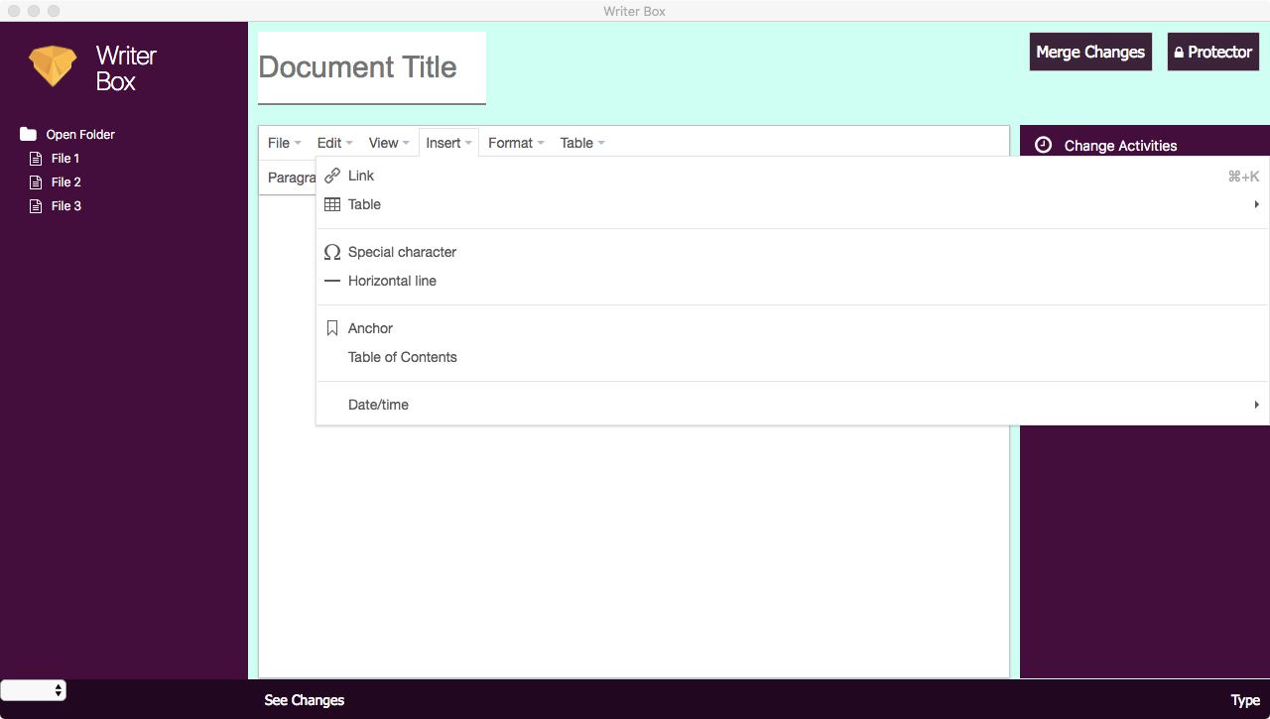
Fig 3. Insert Menu

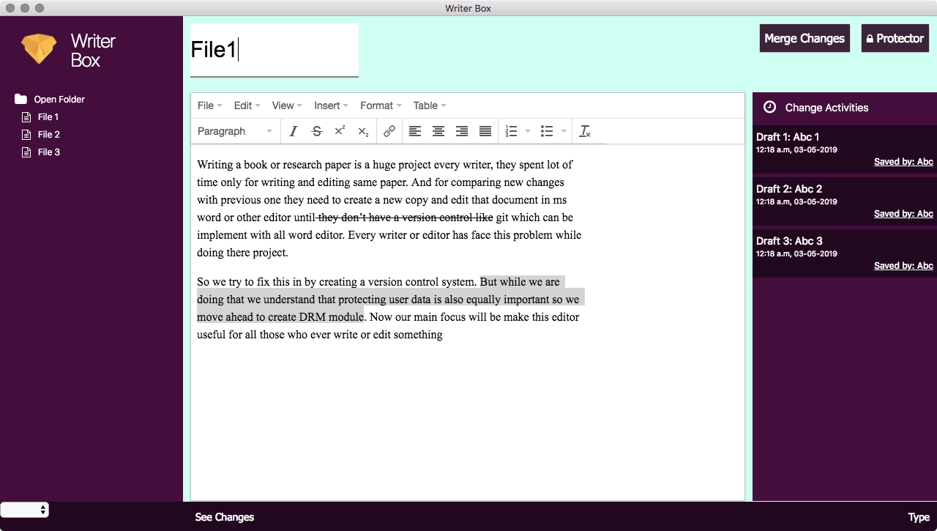
Fig 4. Showing difference (strikeout shows deletion, highlight shows addition or changed)

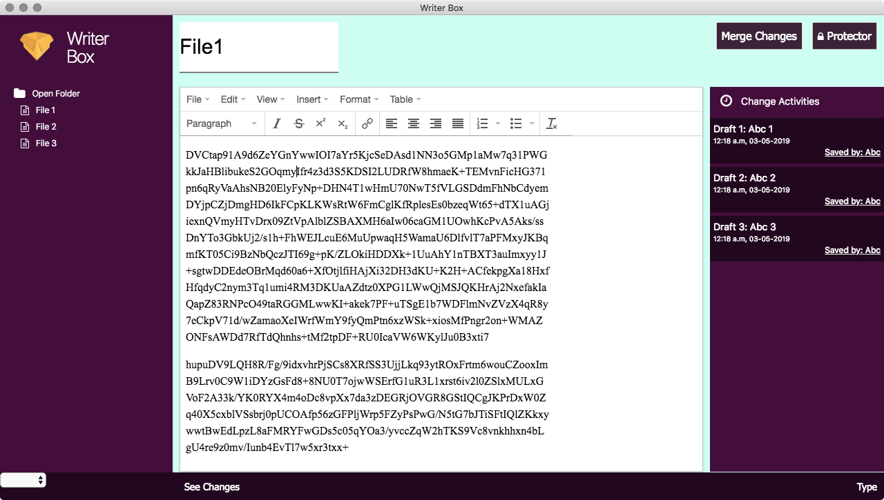
Fig 5. Encrypted File (AES128 encryption algorithm used)

